***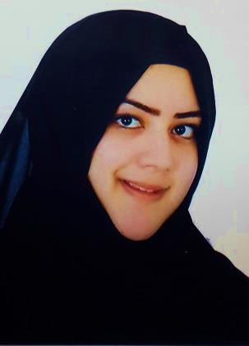*Noor Saeed Mirza Abbas Alhawaj**

Address: villa 1400, Road: 6027, Sanabis 406

Contact: 33630555 – 33112748

E–mail: [nono_7lwa@msn.com](mailto:nono_7lwa@msn.com)

|  |
| --- |
| **Objectives:** |

I want to succeed in a stimulating and challenging environment that will provide me with advancement opportunities. I am also looking for a career that would help me obtain professional responsibilities, enhance my capabilities, learn more and prepare myself efficiently to take up major

|  |
| --- |
| **Education:** |

**2010 To 2015 (LLB) in Law**

**College of Law - University Of Bahrain**

|  |
| --- |
| **Training Experience:** |

**March 1st to April 30th 2016 A.Wahab Kikso Attorney Office**

Trainee Lawyer

**Main Duties and Responsibilities:**

* Assisting the Lawyers in day to day tasks and assignments.
* Review cases documents and prepare cases files.
* Draft and type court replies and other correspondence.
* Open new cases files and prepare all related documents.
* Filing of all cases documents.

|  |
| --- |
| **General Skills:** |

* **VERBAL COMMUNICATION:** Able to express ideas clearly and confidently in speech
* **TEAMWORK**: Work confidently within a group
* **ANALYSING & INVESTIGATING:** Gather information systematically to establish facts & principles. Problem solving.
* **INITIATIVE/SELF MOTIVATION:** Able to act on initiative, identify opportunities & proactive in putting forward ideas & solutions.
* **PLANNING & ORGANISING:** Able to plan activities & carry them through effectively.
* **FLEXIBILITY:** Adapt successfully to changing situations & environments.
* **TIME MANAGEMENT:** Manage time effectively, prioritizing tasks and able to work to deadlines.
* **Languages:** Fluent in English and Arabic

|  |
| --- |
| **Personal information:** |

**Nationality:** BAHRAINI

**CPR:** 920108652

**Date of birth:** 7/1/1992

**Marital status:** Married

|  |
| --- |
| **Hobbies:** |

* Reading books
* Drawing